# Recursive Function Assignment

1.WAP to calculate the maximum stack depth of a recursive call to a function. (For eg a factorial function ).

Ans:

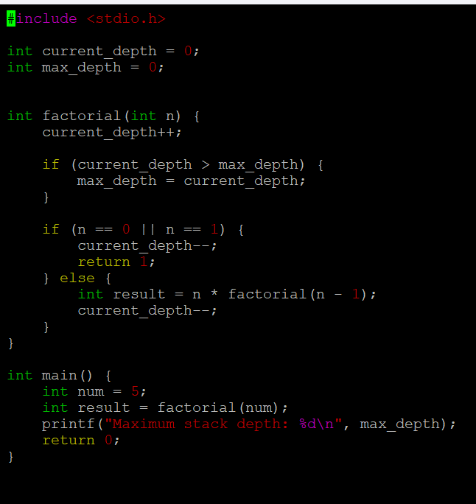

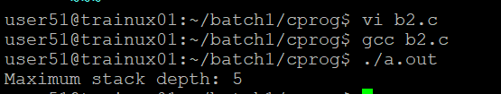

2.What is tail recursion? Why is it important? Give an example

Ans: Tail recursion: t**ail recursion** is a special case of recursion where the recursive call is the **last** operation in the function. In other words, the function returns the result of the recursive call directly without performing any additional computation after the recursive call.

Advantage: Optimized Memory Usage, Performance, Readability and Elegance



